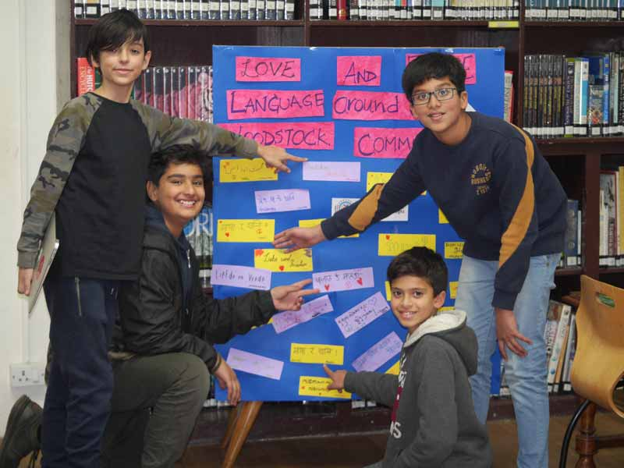
Mother knows Best
With more than 50 languages spoken by our students, Woodstock is a hugely diverse linguistic community. As a school it's something we actively embrace. For students for whom English is a second language we encourage them to keep developing their first language, and to share and use the depth of knowledge they have gained from it.
Thursday marked this year's International Mother Language Day. This day of celebration promotes awareness of linguistic and cultural diversity. A new display of colourful flags displaying our Guiding Principles in dozens of different languages and scripts now adorns the High School. The flags were made by Mrs Sue Long and designed with the support of 11th graders Pooja Shankar and Tala Bagh, along with many students and staff who helped with the translations. Woodstock Library put on several linguistically linked events during the day, including a world map where students could write their language in their native tongue and stick it on the globe.

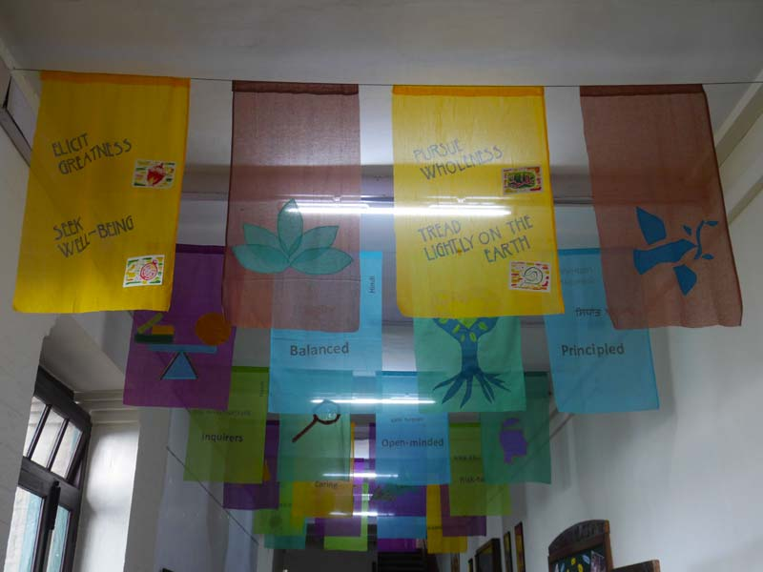

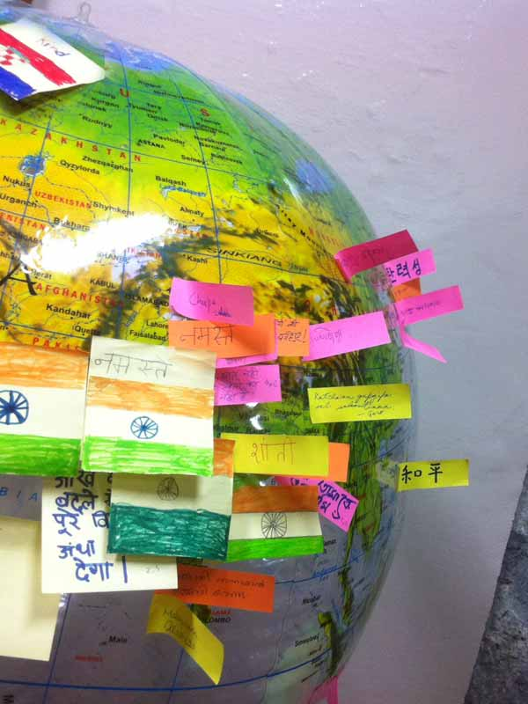
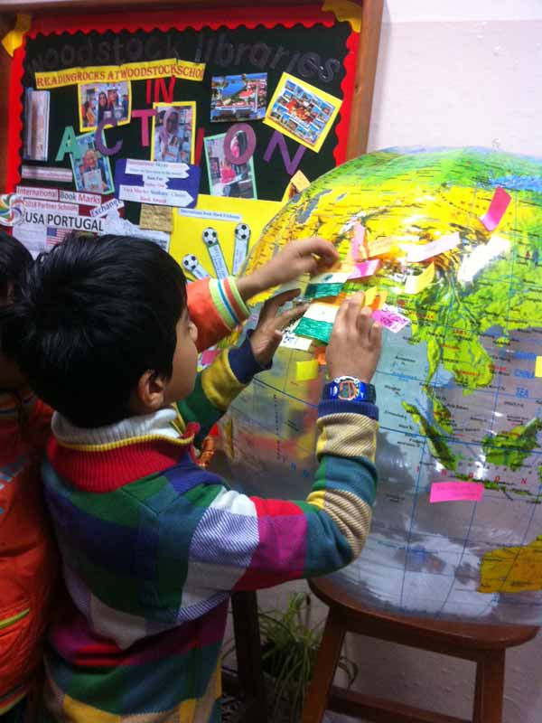

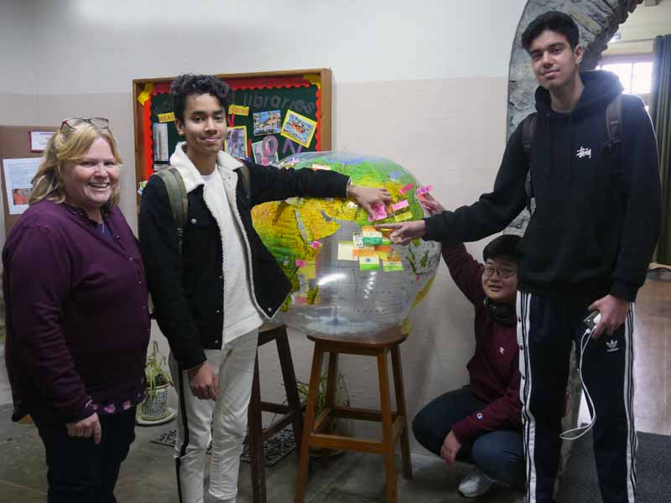

There are more events in the coming months to advocate and promote Indigenous languages in and around Woodstock school.

