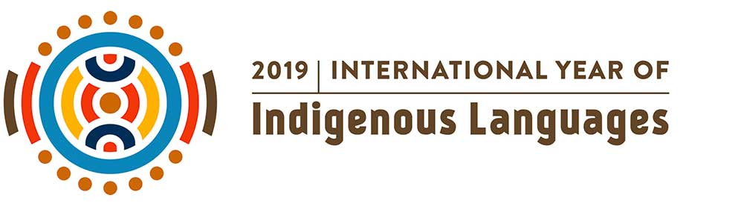
Lesson Activity: Create a ‘chatterbox’
Aim: To raise awareness of Indigenous languages
Specifically the Ainu (Indigenous people of Japan) and Australian Aborigines
- Discussion points: What is the official language in our country? Are there other languages spoken in our country? Are there indigenous languages spoken in our country?
- Show images of Ainu and Australian aboriginals (see below)
- Practice writing the word ‘Mum’ in English, Japanese, Ainu and Baradha (taking care with stroke order – see below)
- Make your own ‘Chatterbox” – see instruction sheets
RESOURCES
- Chatterbox template, instructions, sample and fold instructions
- Ainu Images
Aborigine and Ainu images
- Words for Mother -Looking at languages – English, Japanese, Ainu and the Baradha language (central Queensland Aboriginal language)
State Library of Queensland Word of the Week
Ainu Museum languages
Ainu Oral Literature
Aboriginal Languages – further lesson ideas and information
Worksheet - Ainu, comparisons to the Australian Indigenous (Aboriginals)
(Document from JapaneseTeachingIdeasWeebly)

