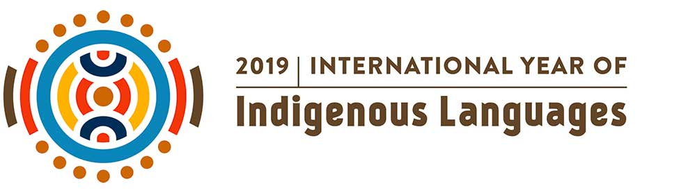
Words for ‘Mother’ in English, Baradha (Central Qld Australian Aboriginal), Japanese and Ainu








母


ハポ

