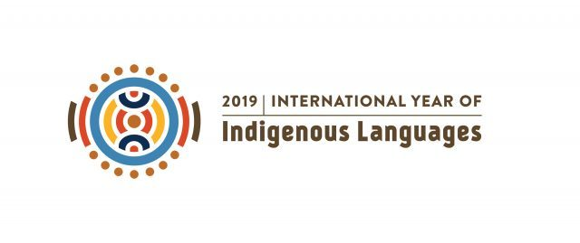

Cookaroo Flow (2018–19)

an installation project by Sydney-based public artist Allan Giddy

__________________________________________________________

Flow is assisted by:

the Australian Government via the Australia Council

the NSW Government via Create NSW

the Aotearoa New Zealand Government via Creative New Zealand

and is endorsed by AIATSIS

(the Australian Institute for Aboriginal and Torres Strait Islander Studies)
Allan Giddy: Flow

CONTENTS
__________________________________________________________

project summary page 3

conception and project development page 4

project development continued (Cookaroo Flow) page 5

Australia page 6

Pacific and International page 7

the artist / previous projects page 8

Allan Giddy: Flow project summary
__________________________________________________________

Launched in the International Year of Indigenous Languages (2019) this participatory, site- and culture-responsive audio installation will utilise the natural flow of water to convey the voices of First Nations children in Australia and around the world, speaking their messages to their own community, Australia and/or the world in their First Languages.
The children’s words, recorded and edited into a soundscape, are being ‘released’ into the water to flow to the oceans.
This work is essentially invisible to passersby, yet the underwater audio can be accessed via a poetically simple means: a stick held with one end in the water, the other against the ear.
As the project progresses, the words that flow from children in Australia and around the world will, metaphorically, eventually meet and mix with each other, and with words from other First Nations cultures around Australia and overseas, in the interconnected oceans of our globe. This intermingling of First Words will symbolise both the strength and support that First Nations cultures draw from establishing relationships with each other globally, and the interdependent nature of all humanity.
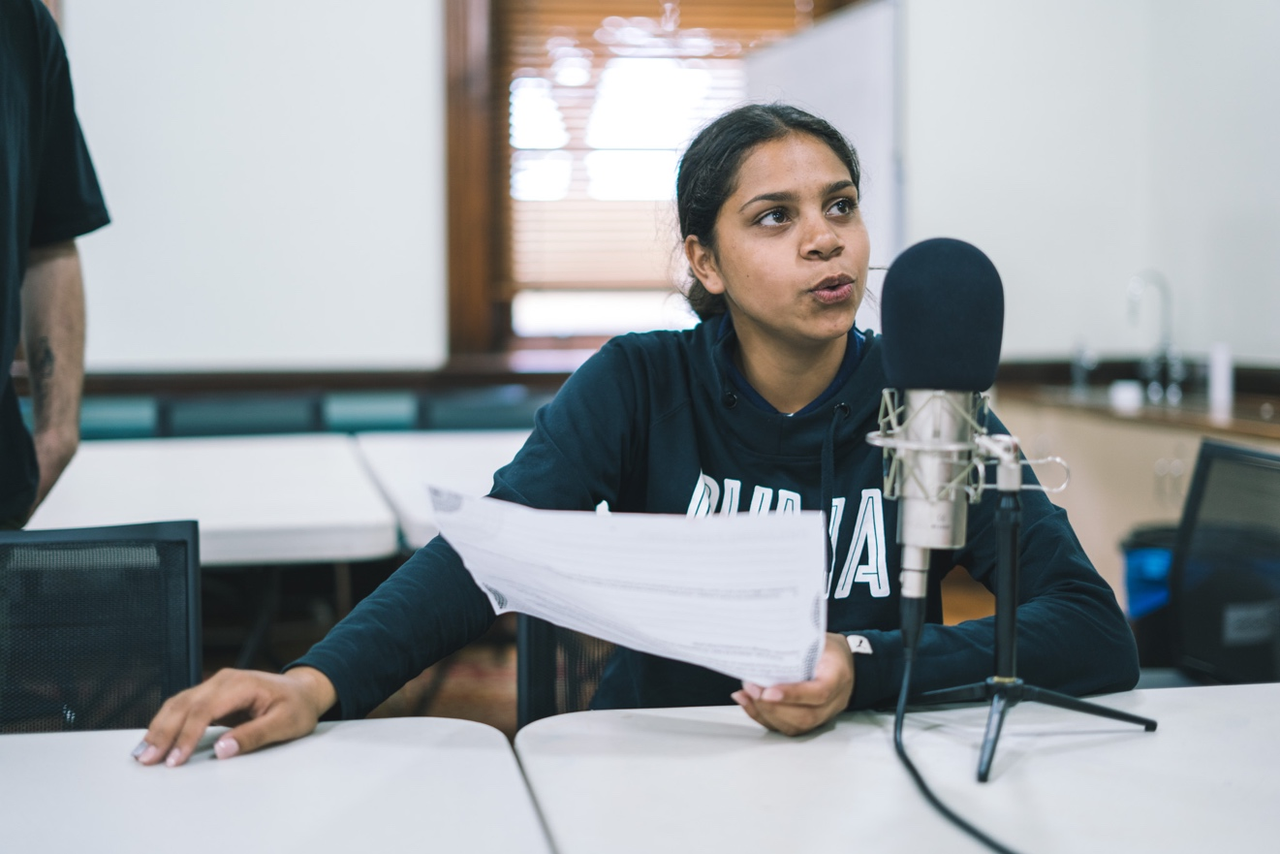

A student from Alexandria Community School, Sydney records her Gadigal poem for Cookaroo Flow in the Royal Botanic Garden Sydney
(photograph: Tad Souden)

Allan Giddy: Flow conception and project development
__________________________________________________________
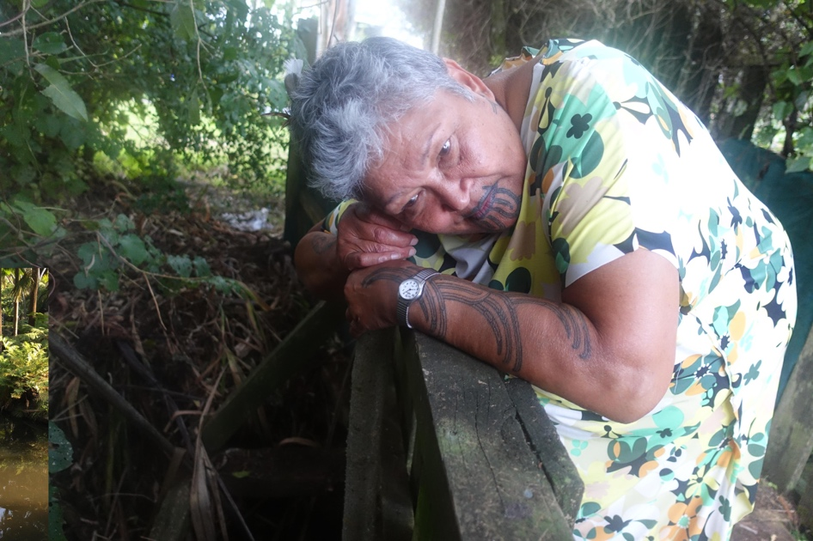

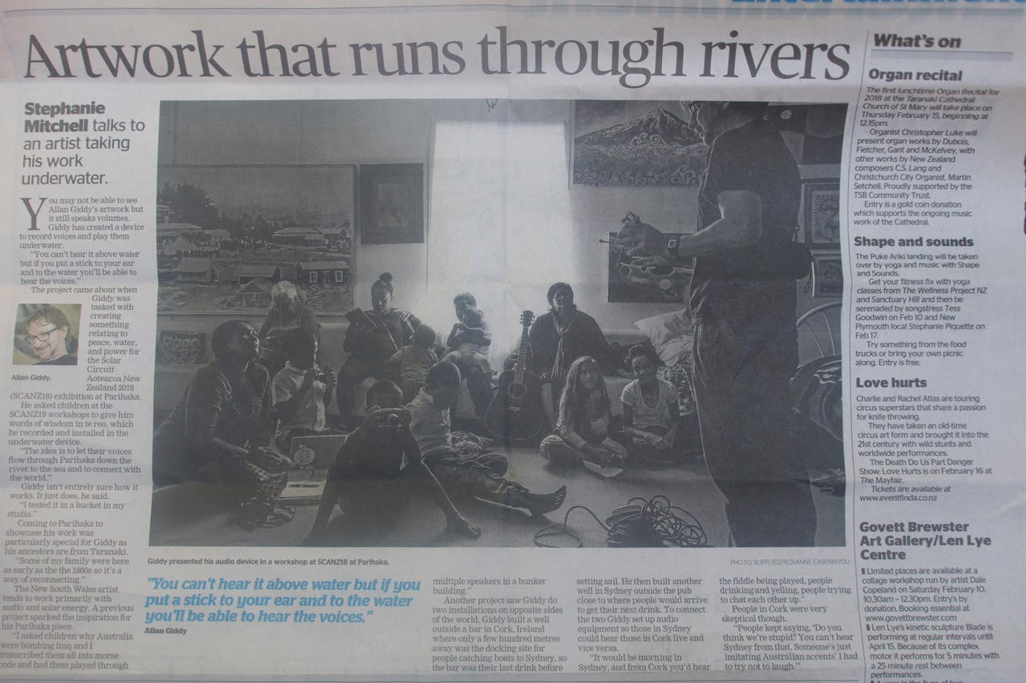
This new work was conceived and prototyped in January 2018 at Parihaka Pa, Taranaki, Aotearoa NZ, with children speaking te reo Māori. The trial was a technical success; and due to the work’s novel accessibility, very popular with participants and other community members.
above: Parihaka Elder Marta Wharehoka listens to the protoype, January 2018

left: Taranaki Daily News (8 February 2018) reports on the prototype developed on residency at Parihaka Pa with children from the local te kura school.
Read the article here

(photographs: Allan Giddy)
Allan Giddy: Flow project development (continued): Cookaroo Flow
__________________________________________________________

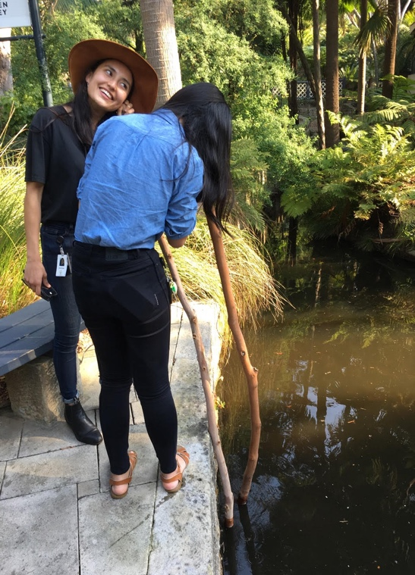
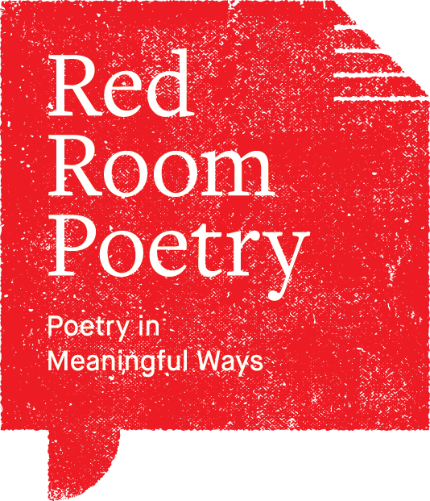
First Nations school students created the audio for the first full public trial of the work in Sydney’s Royal Botanic Garden, which ran from November to February 2018–19.
Red Room Poetry—“Australia’s leading organisation for the creation and commissioning of new poetry by established and emerging poets”—presented ‘Poetry in First Languages’ (PIFL) workshops for local students and some visiting from the NT, in the Botanic Garden in November 2018. During the workshops Allan recorded the students speaking poems they’d written in Gadigal, Anmatjere/Warlpiri and Western Arrernte, then edited them to create the underwater soundscape.
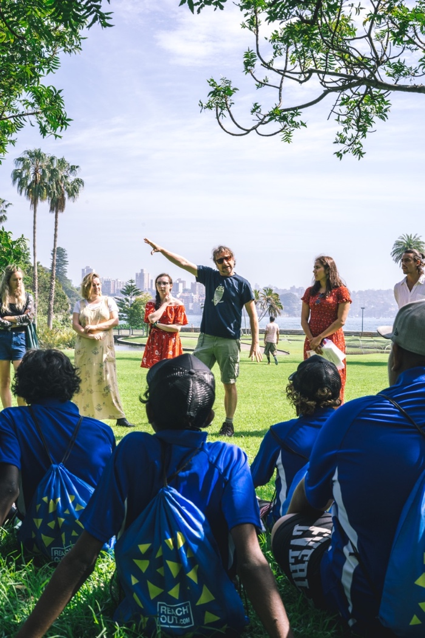
The title of the Botanic Garden installation was Cookaroo Flow (Cookaroo being the Gadigal name for the land on which the Botanic Garden is situated), and the title of each subsequent iteration of Flow will incorporate the First Name of the location.

above: an early technical trial in the Royal Botanic Garden Sydney
(photograph: Allan Giddy)

right: the artist (centre) with Gunai poet Kirli Saunders (Red Room’s Manager: Poetic Learning / Aboriginal Cultural Liaison / creator: Poetry in First Languages project) to his left / our right, introducing the project to students who participated in PIFL and Cookaroo Flow
(photograph: Tad Souden)

Allan Giddy: Flow Australia
__________________________________________________________

Cookaroo Flow was very popular with visitors to the Royal Botanic Garden Sydney during the three-month installation period, and during that time Allan was awarded funding by the Australia Council for the Arts (the arts funding body of the Australian Federal Government) and by Create NSW (the arts funding body of the New South Wales State Government), to create a total of 4 more iterations of Flow, 2 in NSW and 2 interstate, with children speaking different Australian Indigenous languages.
Allan has created the audio for Bungli Flow (see https://en.iyil2019.org/events/bungli-flow/ ) and will go to Tuggeranong (in Australian Capital Territory) in November, and to Perth (in Western Australia) in December, to create iterations with children speaking Ngunnawal and Nyoongar languages respectively.

Meanwhile we’re also talking with:
- Tandanya National Aboriginal Cultural Institute and Adelaide Botanic Garden (TBC) in South Australia
- Victorian Aboriginal Corporation for Languages (VACL) and Royal Botanic Garden Melbourne
- Brisbane City Council
about plans for SA, Victorian and Queensland iterations of Flow.

Canberra
In Australia, Allan plans to create iterations of Flow in each state and the two major territories (ACT and NT), and eventually to install all Australian iterations in Canberra, possibly in Lake Burley Griffin (pending the approval of the United Ngunnawal Elders’ Council). Both the National Capital Authority and ArtsACT are strongly supportive of this plan.
Allan Giddy: Flow Pacific and International
__________________________________________________________

Aotearoa NZ

In November Creative New Zealand (the arts funding body of the New Zealand Government) are funding an iteration in Rotorua, North Island. Allan will work with First Nations students at his own primary school, Malfroy Primary School, where the children will create messages in te reo Māori, and also with students at his high school, Rotorua Boys’ High, students of Whakairo (Maori carving) will carve into the poles used in the installation. Rotorua Lakes Council, with approval by Te Arawa Trust, are facilitating the installation of the work on Ngati Whakaue Tribal Lands on the lake front (Lake Rotorua) throughout the summer 2019–20 (see https://en.iyil2019.org/events/rotorua-flow/ ).

Over the next couple of years Allan intends to create a set of iterations of Flow featuring Pacific Island nations (on some of which First Languages are already suffering from the cultural dispersal that is one inevitable result of climate change).

As the project progresses Allan will also consider taking the project to First Nations communities in other countries such as Canada and the USA.
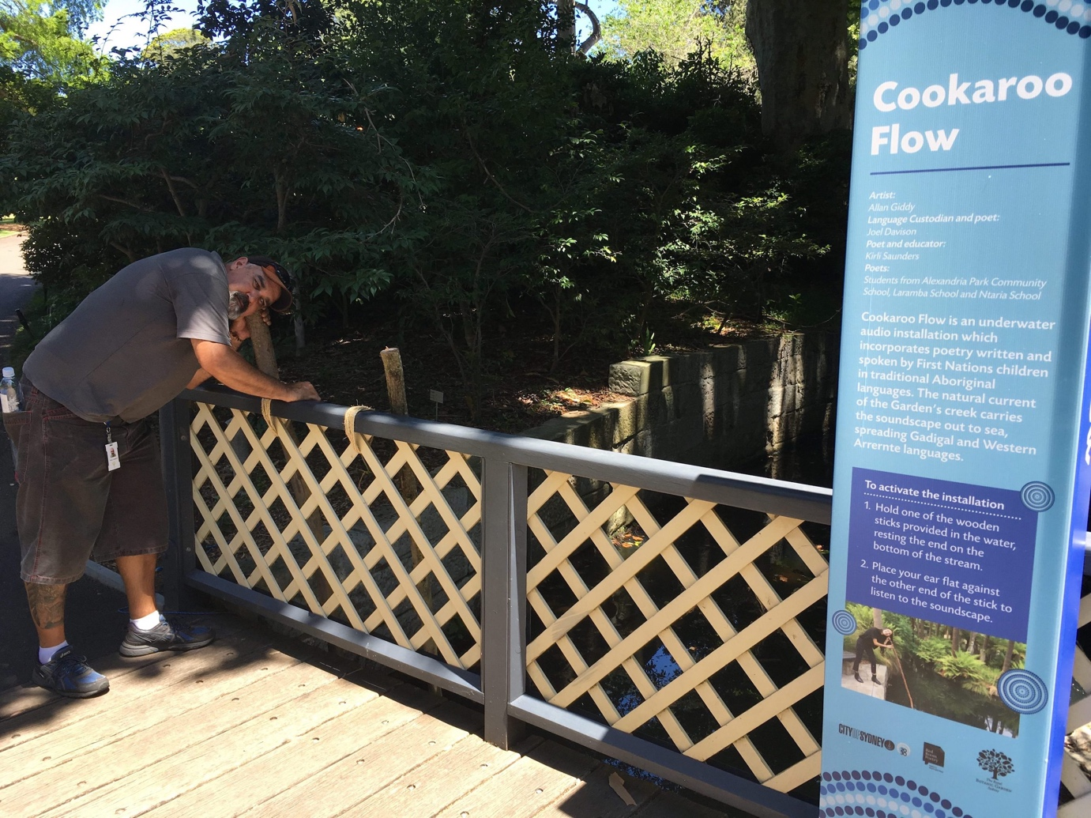

Aboriginal Education Officer Terry Crawford experiences Cookaroo Flow in the Royal Botanic Garden Sydney (January 2019)
(photograph: Allan Giddy)

Allan Giddy: Flow
the artist / previous projects
__________________________________________________________

Sydney-based public artist Allan Giddy is a pioneer in the use of sustainable energy systems and light in ‘time-based sculpture’, and is the founding director of the Environmental Research Institute for Art (ERIA) at UNSW Art & Design.

Allan’s work has been shown at the Tate Modern, in ISEA and TISEA (International Symposia on Electronic Art), and numerous other venues internationally.

Allan’s public installations include:

Sonic Wells for Gallipoli (2016: three months, in three countries, connected in real time by the artwork, working with three municipalities and funded by three major grants)

Earth v Sky (2012: for City of Sydney, permanent)

Weather Cranes (2007: for Sydney Olympic Park Authority, permanent)

A past winner of NSW’s most prestigious travelling art scholarship (now called the Helen Lempriere), Allan regularly engages in industry and other partnerships to achieve his projects, including with: AGL Solar, Living Power, Silex Solar, BP Solar, UNSW’s Centre of Excellence for Advanced Silicon Photovoltaics and Photonics, Jaycar Electronics, Fujitsu, City of Sydney, Caroma, Sydney Olympic Park Authority, Randwick City Council and Pepperl and Fuchs Gmbh.

Over the last decade Allan has expanded his practice into the public domain, specifically
public sited ‘active sculpture’, and has completed a number of large public commissions, in
Australia (including permanent works for City of Sydney and Sydney Olympic Park Authority), China, Ireland, Germany, the UK and Aotearoa New Zealand.

Allan has also conceived and curated many high-profile public exhibitions, many of them involving energy, including:

- Desert Equinox (Broken Hill, NSW, 2012), Australia’s first public solar art exhibition
- La Lune: Energy Producing Art (2014), which was runner-up in two categories of the Australian Event Awards that year (Best New Event and Best Achievement in Sustainability)
- NOX Night Sculpture (Randwick, NSW, 2015/17/19) which won a Highly Commended award in the Creative Communities category of the NSW Local Government Excellence Awards in 2017 and is now a biennial event
- WAR – A Playground Perspective (2016), the biggest exhibition ever staged at the Armory Gallery and surrounds, Newington Armory, Sydney Olympic Park.

For more on Allan’s past works see: http://allangiddy.org

