Kaurna Playing Cards blurb

This is a ‘standard’ set of playing cards, except that the language is Kaurna and the suits are a Kaurna cultural adaptation.
Playing cards originated in China over 1,000 years ago. They reached Europe via Egypt about 660 years ago. Playing card suits have changed over the years. In Mamaluke Egypt they were goblets, gold coins, swords and polo sticks. In Europe the polo sticks became batons or staves, and to this day these are the traditional suitmarks on Italian and Spanish cards. On German cards they became acorns, leaves, hearts and bells. In the International Year of Indigenous Languages, we have adopted a set of suitmarks that celebrate Kaurna culture:

Murlapaka (Kaurna shield) = hearts

Tamiaku (stone axe) = diamonds
Wirri (club) = clubs
Kuru (coolamon) = spades
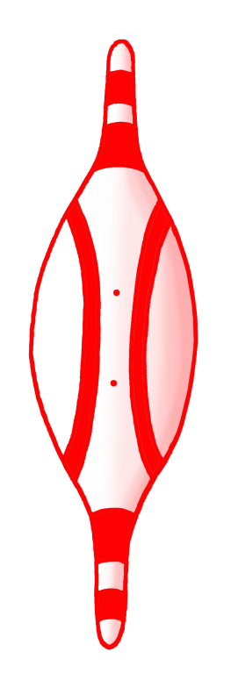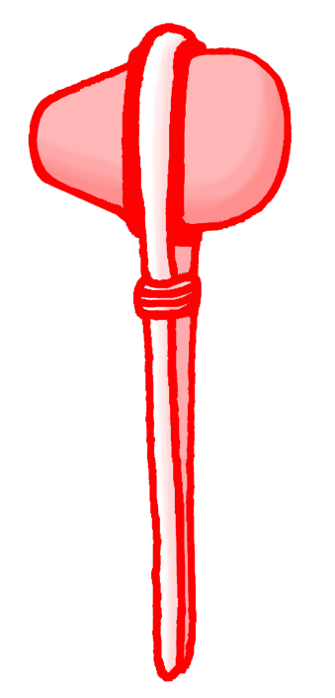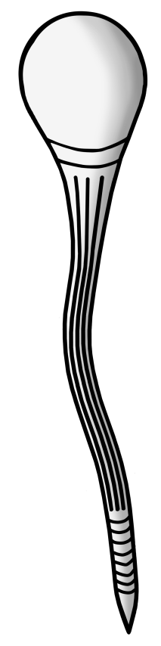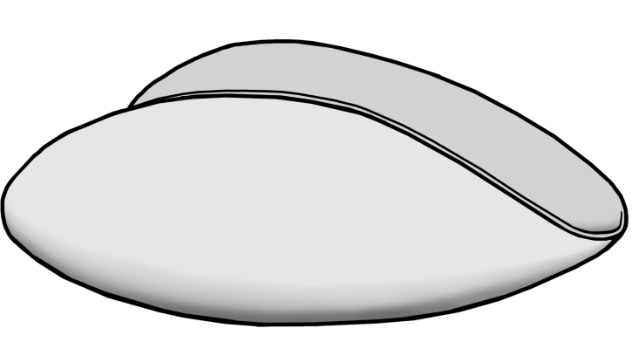
Murlawirrapurka (King John) = King
Ivarrityi (Princess Amelia) = Queen
Kadlitpina (Captain Jack) = Jack
Jack Kanya Buckskin = Joker
