A festival of Kumandin culture was held in Biysk, as part of the celebration of the International Day of the Indigenous Peoples of the World. This is not the first festival in the history of the Kumandin people, before that it was held in the villages of Krasnogorskoye and Salton, in the Altai Mountains, however, future festivals are planned to be held there.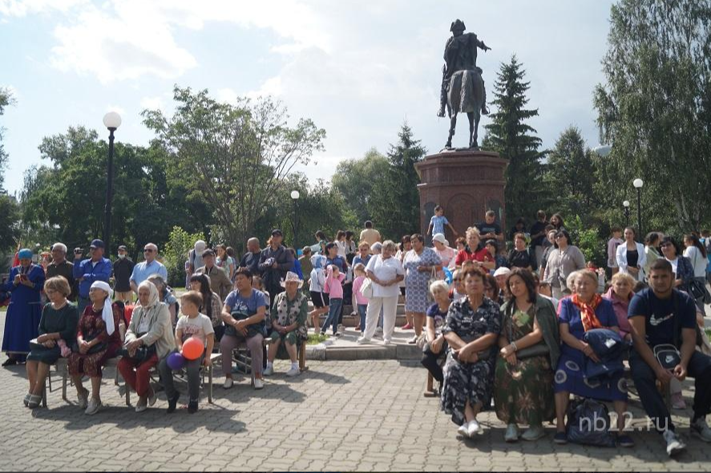
I would like to note that the culture festival has been held in Biysk for the 19th time. Which testifies to the historical significance and popularity of this festival. A bright, emotional event brought together representatives of the Kumandin people living in Salton. Such coverage allowed about three hundred people to take part in the holiday.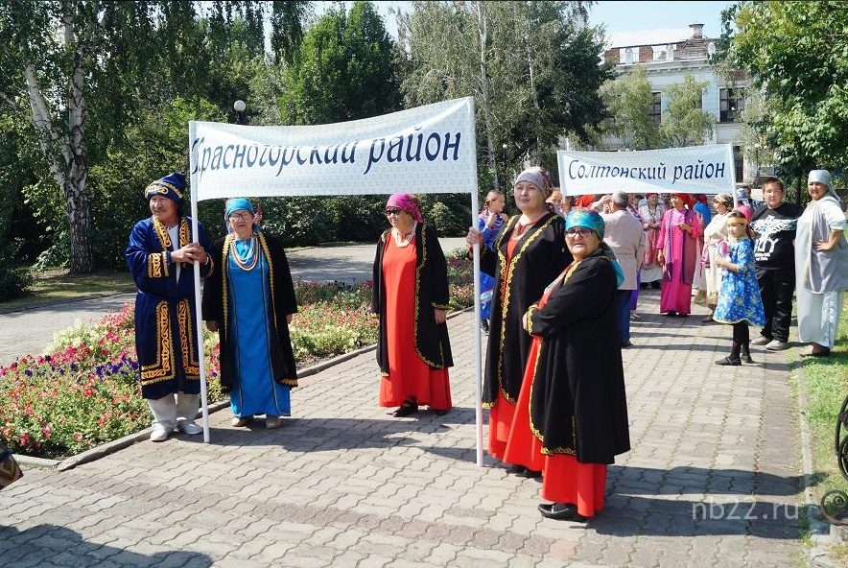
The representatives of this people heard the first congratulations from the chairmen of the societies and representatives of the administration. "Izynyr! - Mikhail Kuzmich Degtyarev, First Deputy head of the administration of the Salton district, greeted everyone, - dear participants of the festival! Today is a meeting day for all of us! We are all like one family!"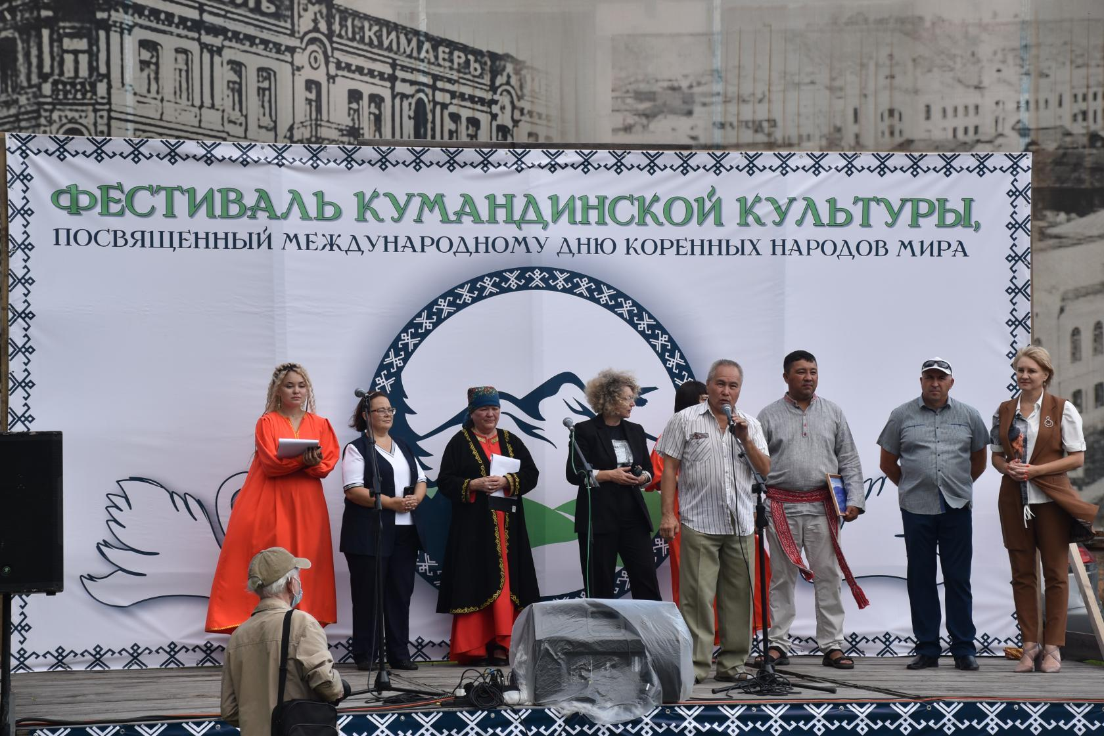
Before the start of the big holiday, all participants in national costumes marched in colorful columns to the stage, where they were greeted with greetings and good wishes by the elder of the Kumandin people Galina Kukhtuekova.
Contests and scenes deserve special attention. So, during the contest "Kumandinskaya beauty", beautiful representatives of the Kumandin family swam onto the stage like swans. The oldest is 18, the youngest is 6 years old. Each beauty told us about which community she came from and what kind of ancestral mountain she had.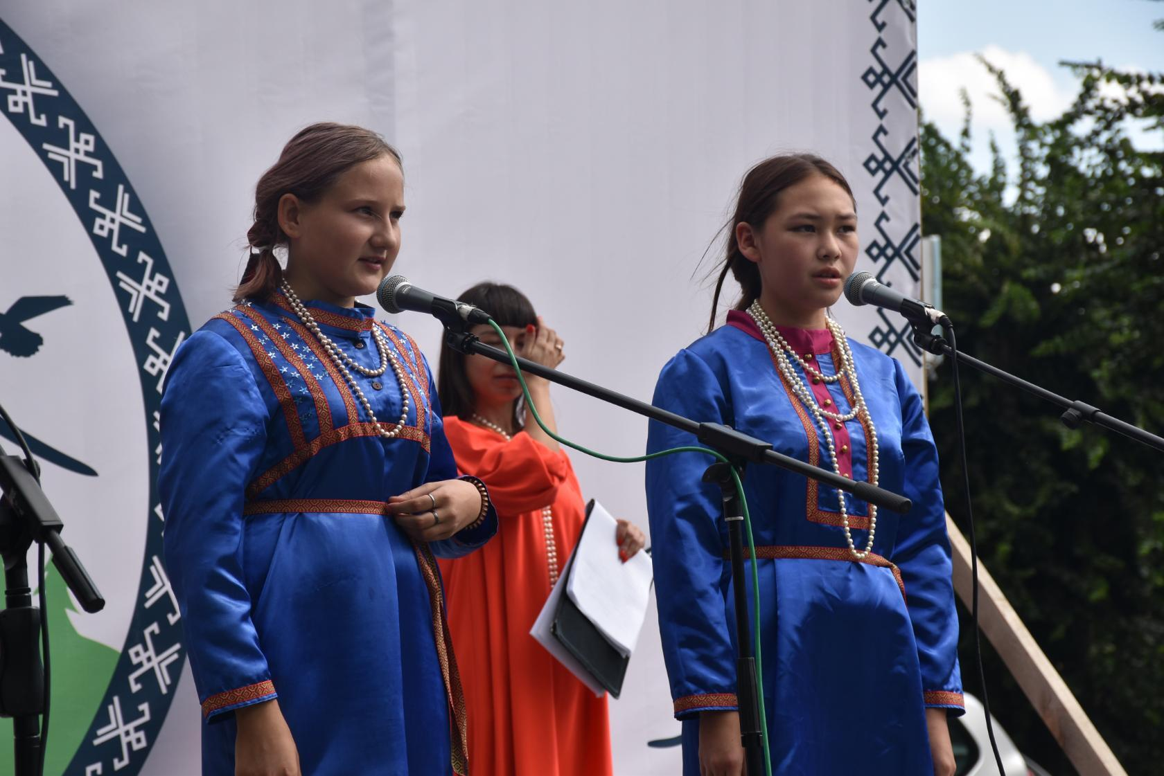

Why did they come out? And this is a kind of reference to the legend of the origin of the Kumandin family. It sounds like this: Three swans were flying, they decided to rest, swim. We went down to the river. Throwing off their snow-white dresses, the swans turned into beautiful girls and happily splashed in the river. The hunter, sneaking up, stole one outfit. The swan girls discovered the loss, two birds flew away, and one became the wife of a hunter. The totem of the Kumandins is a swan.
Kumandinki in elegant ponevas, sang a song in their native language, holding national handmade products in their hands.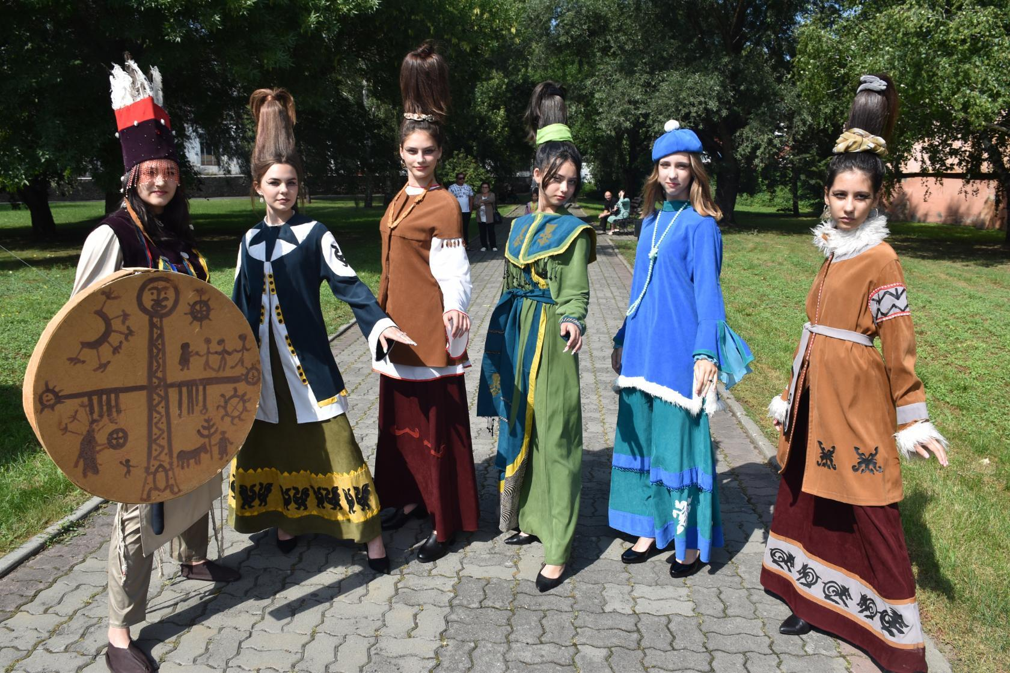

At the event site, women worked at tables and competed in the preparation of national dishes. The women chatted merrily, joked, sportively cut meat, rolled dough, lit a fire. Guests were offered to try neat slices of black pudding.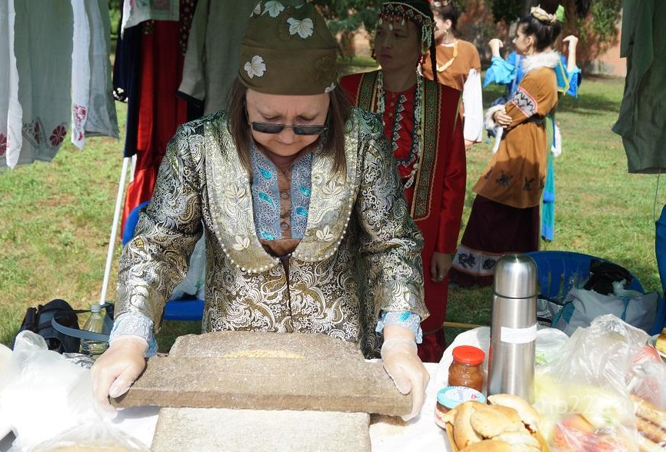

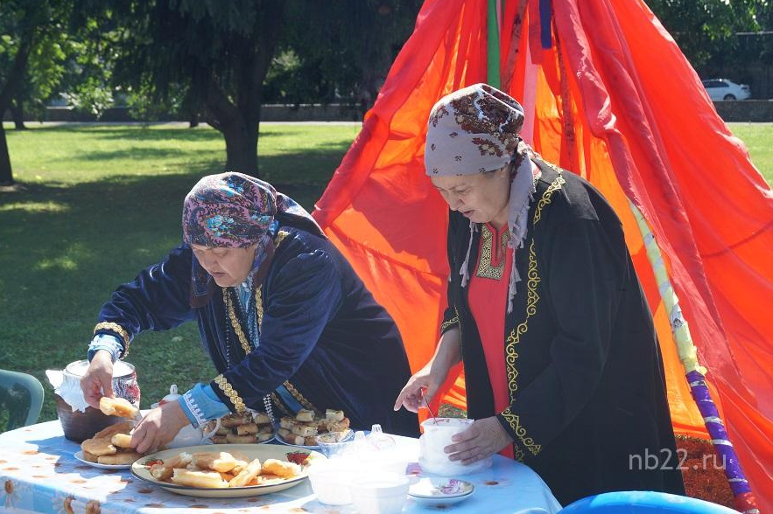

There was a presentation and tasting of national dishes. The guests noted that large portions were offered for tasting and everyone had the opportunity to taste the Kumandin cuisine.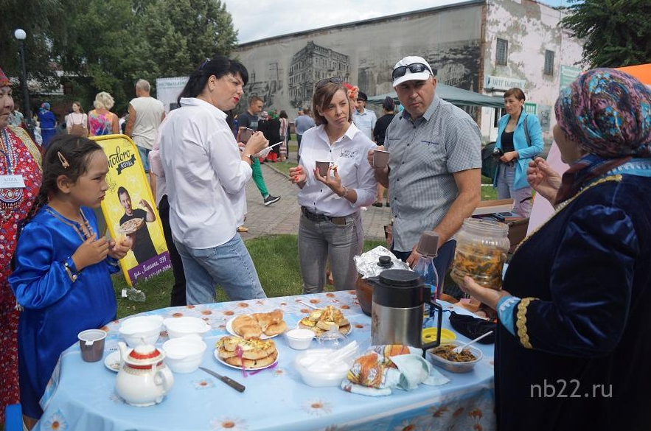
Competitions among men in stone throwing "shel tal", stone lifting "kuderte tash", arm wrestling, mini-football and running in bags were held on the field. And then the winners were announced.
In the competition for the preparation of dishes of national cuisine, the victory went to Biysk chefs.
In conclusion, I would like to note that the Kumandins carefully preserve their traditions and customs, the nature and beauty of a culture that has survived centuries, entrenched in folklore: dances, songs, fairy tales. We are looking forward to the next festival!