The Оpen Corpus of the Veps and Karelian Languages (VepKar)
An online linguistic corpus of the Vepsian and Karelian languages has been developed in the Republic of Karelia. The Оpen Corpus of the Veps and Karelian Languages (VepKar) is an electronic information and reference system, which is developed jointly by specialists from the Institute of Language, Literature and History and the Institute of Applied Mathematical Research (KarRC RAS) for over ten years. VepKar is a continuation of the Veps Corpus project developed by Nina Zaiceva since 2009. The corpus was extended to include the Karelian language in 2016.
The VepKar includes the Veps language, Karelian Proper, Livvi-Karelian and Ludic Karelian dialects, all of them have newly created writing tradition.
The corpus website contains various types and genres of labeled texts (dialect, folklore, biblical, journalistic texts etc.), as well as different dictionaries. The Speech сorpus contains texts with audio recordings. The VepKar corpus data is the basis for growing resources such as the Baltic-Finnish Audio Map of Karelia and the Karelian Multimedia Dictionary (LiPaS – Livvin paginan sanat).
A related set of concepts extracted from the “Comparative and Onomasiological Dictionary of the Karelian, Vepsian and Sami Languages” (2007) is presented on the VepKar website. VepKar editors may add an illustration with an open license (for example, from Wikimedia Commons) to these concepts. There are one and a half thousand concepts in VepKar that can be provided with illustrations (http://dictorpus.krc.karelia.ru/en/dict/concept).
The developed corpus manager is an open source project Dictorpus available at GitHub (https://github.com/componavt/dictorpus). The corpus database, including dictionaries and texts, have an open license (CC-BY). You can use this resource for any purpose, including commercial.
Welcome to The Open Corpus of Veps and Karelian Languages website: http://dictorpus.krc.karelia.ru.

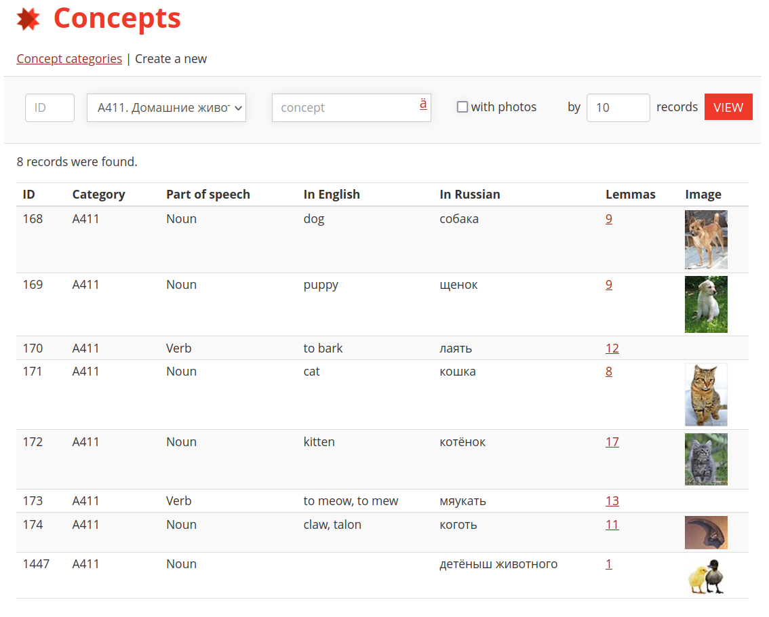
A related set of concepts extracted from the “Comparative and Onomasiological Dictionary of the Karelian, Vepsian and Sami Languages” (2007) is presented on the VepKar website. VepKar editors may add an illustration with an open license (for example, from Wikimedia Commons) to these concepts. There are one and a half thousand concepts in VepKar that can be provided with illustrations.

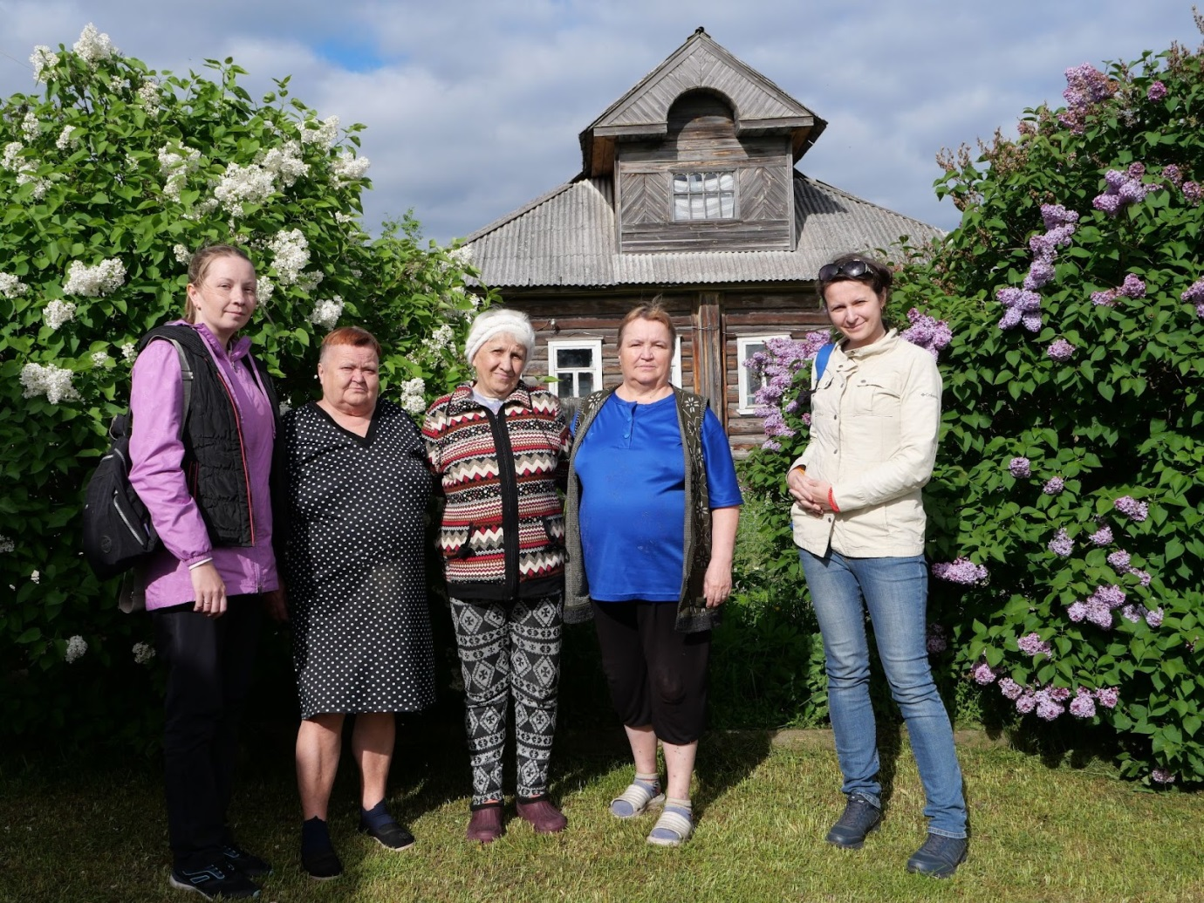
Editors of the linguistic corpus VepKar and residents of the village of Selgi in Karelia, 2022.

