Paratype — fonts,

which do work

Paratype — is the first font studio in Russia. It has been operating as an independent company since 1998. Paratype font library has existed since the late 1980s. Paratype multilingual fonts support about 200 languages of the world based on Cyrillic, Latin, Greek and other scripts.

More than

1400

fonts
Paratype's collection of typefaces is constantly expanding. The modern UICODE – a compatible text encoding standard – supports all languages of the subjects of the Russian Federation that are written with Cyrillic script. Free fonts (RT Public Pack) cover alphabets of more than 150 Cyrillic-alphabet languages and dialects, including indigenous languages of the North, Siberia and Far East.

Languages supported by Standard Cyrillic encoding | Languages supported by most Paratype fonts | Languages (in addition to the second column) supported  by the PTGL-Paratype Glyph List language standard
Belarusian | Abazin | Aleut | Kalmyk | Selkup
Bulgarian | Adyge | Altaic | Karakalpak | Shor
Macedonian | Aghul | Alutor | Kazakh | Soyot
Mordvin-Erzya | Avar | Azeri | Khakass | Tadzhik
Mordvin-Moksha | Chechen | Balkar | Khanty | Talysh
Russian | Dargwa | Bashkir | Kirghiz | Tat
Serbian | Dungan | Buryat | Komi-Permyak | Tatar
Ukrainian | Ingush | Chelkan | Komi-Zyrian | Telengit
 | Kabardian | Chukchi | Koryak | Teleut
 | Kabardino-Cirkassian | Chulym | Kryashen Tatar | Tofalar
 | Karachay-Balkar | Chuvash | Kumyk | Touva
 | Lezgin | Cirkassian | Kurdish | Tuba
 | Nogai | Dolgan | Manci | Turkmen
 | Ossetic | Enets | Mari | Udmurt
 | Russian | Eskimo | Mari | Uighur
 | Russian Old (XIX) | Even | Moldavian | Ulch
 | Rutul | Evenki | Mongolian | Uzbek
 | Tabasaran | Gagauz | Nenets | Yakut
 | Tsakhur | Itelmen | Oroch | Yukagir

There are also a number of Latin-based languages: Karelian, Livvikovsky, Ljudikovsky, Sorbian Lower, Sorbian Upper, and Veps. The expert typefaces – RT Sans and RT Serif – additionally support a number of minority languages.
Among them: Itelmen, Negidal’skij, Nganasan, Nivkh, Orok, Selkup, Tat, Udehe, and Ulch.

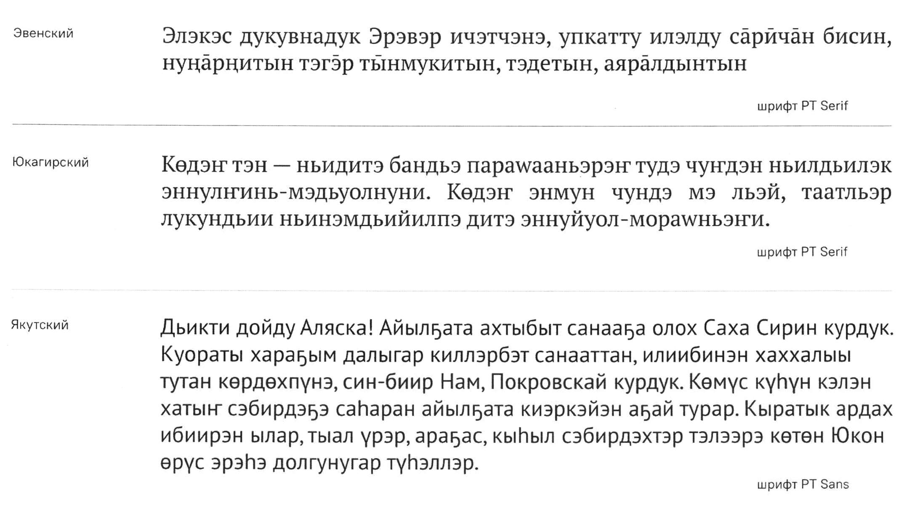
Yukaghir language
Yakut language
Font PT Serif
Font PT Sans
Font PT Serif
Even language
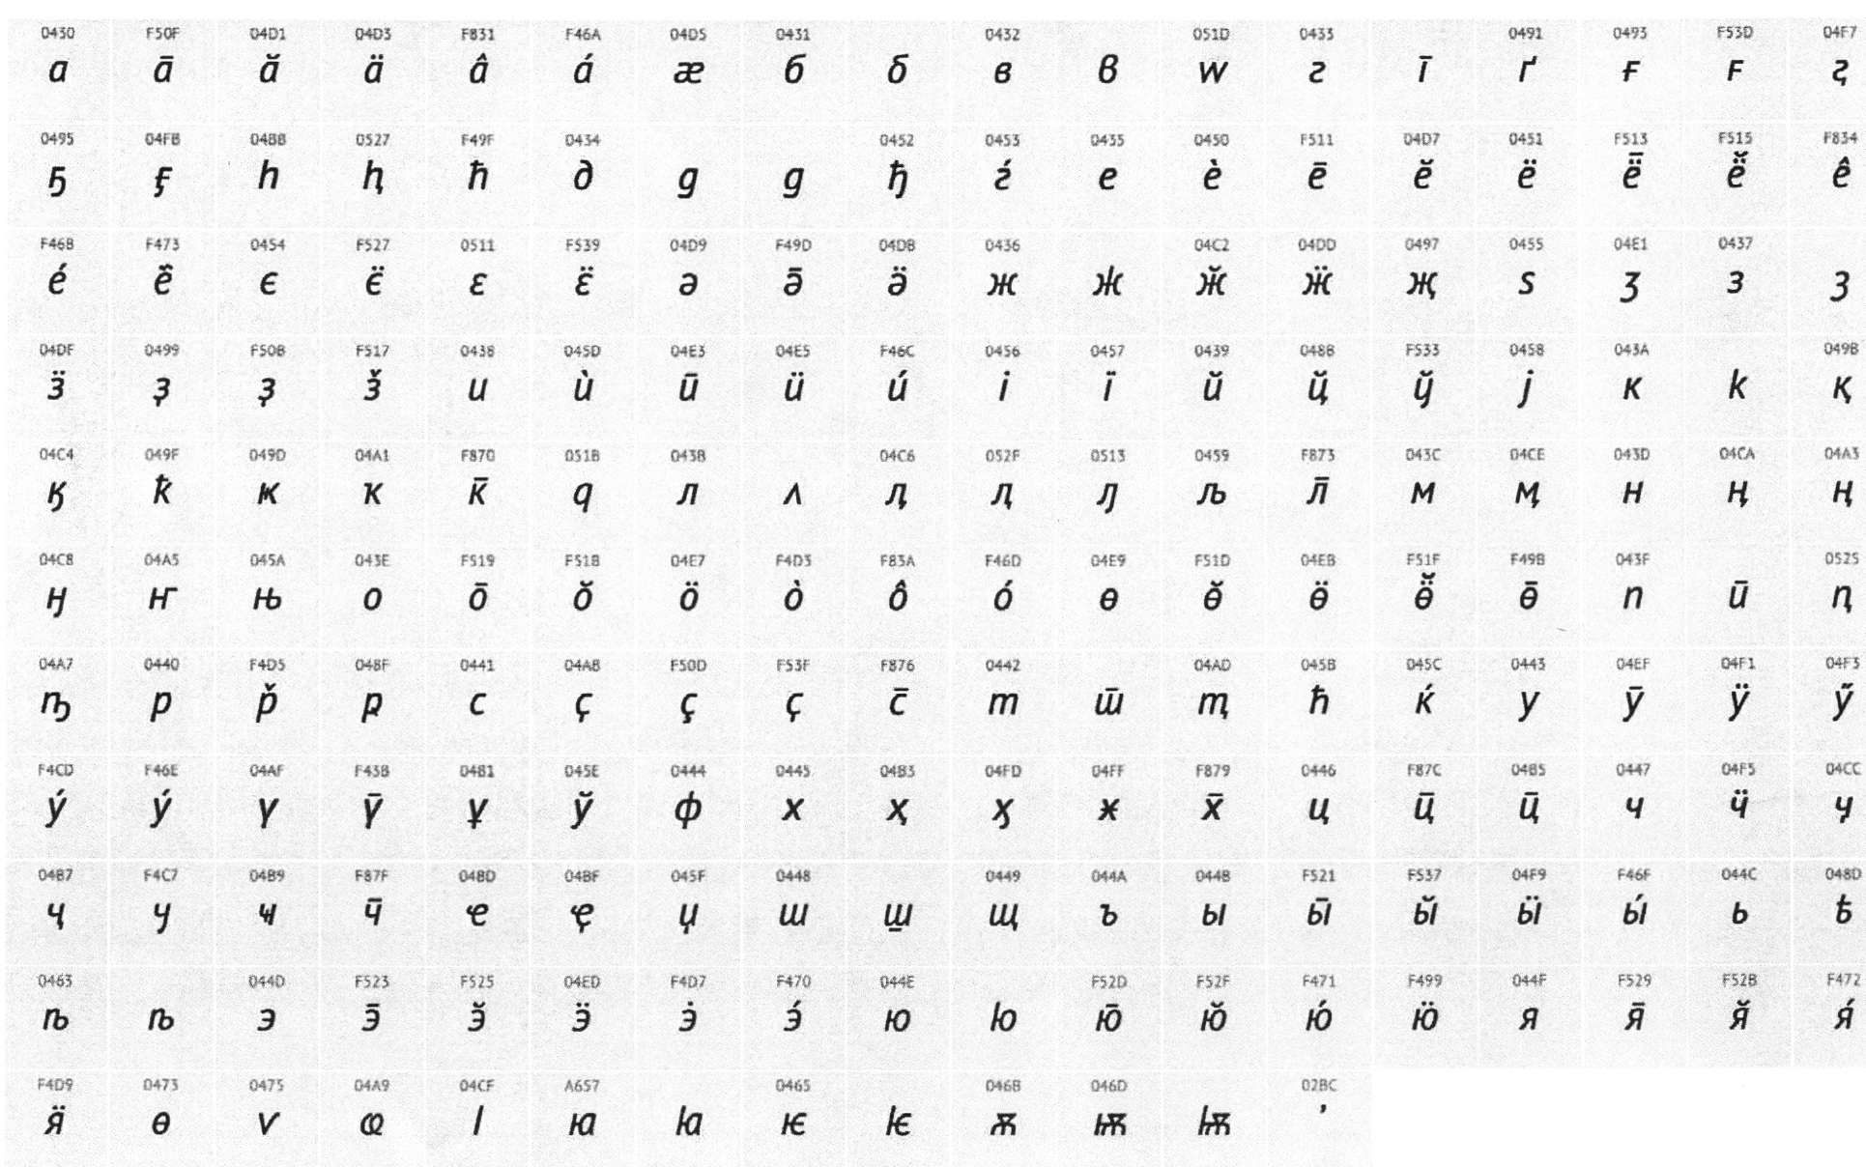
When developing new fonts, Paratype uses the full alphabet, including not only all characters of Cyrillic script-based languages, but also local alternative forms traditionally used for some languages (Bashkir, Bulgarian, Serbian, Macedonian, Chuvash and some others).

A distinctive feature of extended Cyrillic in Paratype fonts is that they support indigenous languages, even in cases where some alphabetic characters are not included in Unicode (a character encoding standard which includes almost all written languages of the world).

A special Unicode Private Use Area is used for such characters of the extended Cyrillic alphabet. The codes assigned to the characters are preserved in all fonts, ensuring correct reproduction of the text when switching from one font to another. The experience of creating multilingual fonts laid the foundation for the Language Guide, which includes almost all written languages based on the Cyrillic alphabet: Language Guide

Extended Cyrillic script
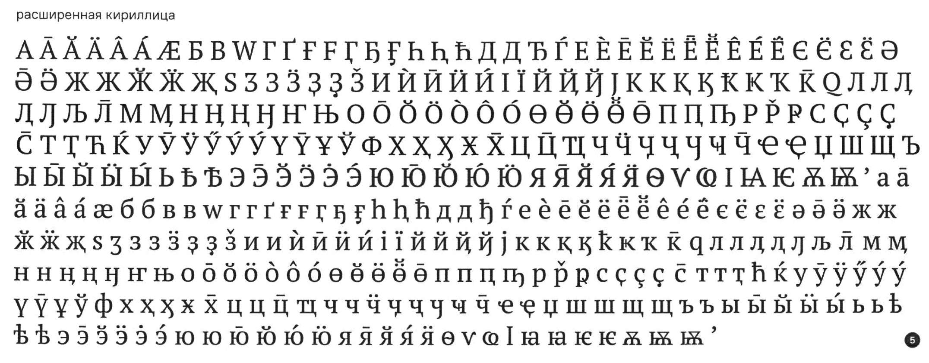

fin580/2023

