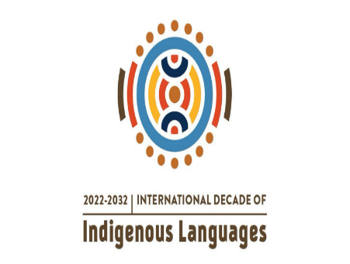
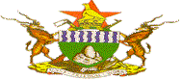
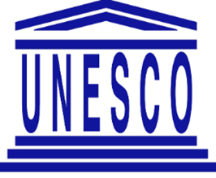

ZIMBABWE REPORT (1ST) ON COMMEMORATION OF THE INTERNATIONAL DECADE FOR INDIGENOUS LANGUAGES (IDIL 2022-2032)
By
Professor W. Magwa (PhD)
Zimbabwe Representative on the Global Task Force of the International Decade of Indigenous Languages

