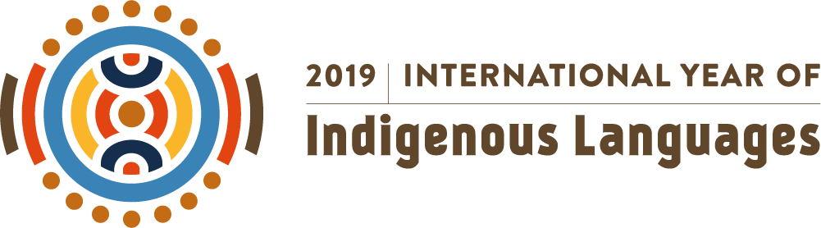

OUTCOME DOCUMENT OF MELANGE – A SYMPOSIUM ON THE INTERNATIONAL YEAR OF INDIGENOUS LANGUAGES 2019 HELD AT NEW DELHI ON 29TH JUNE, 2019

- Introduction:

The United Nations’ vide its resolution number 71/178 dated 19th December 2016 declared the year 2019 as the International Year of Indigenous Languages. The Resolution, was based on the recommendations of the permanent forum on indigenous languages and guided by the United Nations declaration on the rights of indigenous people 2007. The core of the resolution as manifested in the UN declaration is that the indigenous people’s deserve the same rights and respect as any other people in the world. It follows from this principle that language and livelihood are intricately linked to the overall societal progress of the indigenous people spread across the globe. The nodal agency for implementation of the UN theme, UNESCO has built up a comprehensive data on the indigenous people around the world. Summarily this data points out to the critical risks faced by Indigenous Languages and the urgent need to save them in the larger interest of ensuring the sustenance of the collective of socio-cultural heritage of the world.

India is a country which continues to grow as one of the most vibrant democracies of the World thriving mainly on its linguistic heritage, tradition and progress in contemporary times. Therefore it is imperative that the endangered indigenous languages as identified by the UNESCO World Atlas needs to be saved with a long- term policy mechanism adequate to overcome this challenge

The objectives of the UNIYIL has been to foster promotion, preservation, reconciliation and development amongst the indigenous people so as to address the challenge of languages heading towards extinction. The multi-stakeholder partnership defined in UN Action Plan gives adequate scope for a wide cross section of partners encompassing all sectors to contribute to the objective.

It is here that Bellwortt International Private Limited conceived an Yearlong Calendar of Activities with this symposium being the first activity/ event to kickstart the process. An array of experts, academics, journalist and researchers including representatives from foreign Nations participated in the One day Symposium dwelling in the different aspects of the issue.

- Highlights of Deliberations

The Speakers including Thinkers, Academicians , Journalists , Scholars deliberated on the multiple dimensions of the state of Indigenous Languages in the country with respect to the following parameters ;

- Multilingualism as a means to ascertain the sustenance of Endangered Indigenous Languages in India . ( Reference : Comments of Mr. Ganesh Devy, Author and Expert on Languages)

- Cultural Expressions as a Manifestation of Linguistic Traditions in India . ( Reference : Comments of Mr. Gaurav Choudhury , Economist & Senior Journalist)

- Cognitive Aspect of Languages ( Reference : Comments of Mr. Ganesh Devy , Author and Expert on Languages )

- The Growing incidence of the use of Bilingualism ( Sekhar Iyer, Senior Journalist)

- Constitutional Perspective
The Symposium dwelled on the Constitutional Aspects of the Endangered Indigenous Languages with the main challenge emerging out of the concern for absence of the use of the word “ indigenous” in any Government of India communication or correspondence .
The lack of state ownership was discussed . The absence of clarity in the institutional mechanism to address the issue was pointed out by many speakers. It was the sense of the discussion which pointed towards a dedicated Government apparatus to be mapped to the multifarious issues of Indigenous Languages.
In the context of the issue of Indigenous Languages, Member of Parliament (Lower House- Lok Sabha) from Assam, Mr. Naba Kumar Sarania called for a constitutional mechanism to include these languages with due constitutional recognition. He also suggested that the issue is adequately addressed in Parliament especially against the backdrop of the fact that the vulnerability of languages which are popular are also increasing .
The House dwelled on the possibility of placing these two issues to the affected states for its inclusion within the broader policy framework of the Government .

- Academic Perspective
Prof Girish Nath Jha , Professor of Computational Linguistics, School of Sanskrit and Indic Studies ,Jawaharlal Nehru University , Delhi gave an overview of the technological aspects of the use of various languages in the various digital /computational media .
Prof (Dr.) Gautam Kumar Jha, Assistant Professor, School of Language , Literature and Culture Studies , Jawaharlal Nehru University , Delhi gave a sociological overview on indigenous languages in India .
- Analysis

Bellwortt International Private Limited presented a detailed overview of the Status of Endangered Indigenous Languages in India . The analysis included

- A State Wise Summary of Indigenous Languages in India
- A Report on the Status of Indigenous Languages in the North Eastern Region of India which is the most affected with 89 of the 197 endangered languages in the country .
- Other Details such as the yearlong calendar of activities for observing the International Year of Indigenous Languages 2019 in India.
- Resolution
It was unanimously resolved to highlight and inform the concerned agencies including the Government of India , State Governments , the United Nations’ Nodal Agencies like UNESCO and others about the deliberations in the Symposium.
All correspondence to these agencies would pertain to the UN Action Plan Intervention Areas.

*** A Special Note on the Presentation by “Indian Languages in the Age of IT”
Prof. Girish Nath Jha
Professor of Computational Linguistics &
Dean, School for Sanskrit and Indic Studies, JNU, New Delhi – 110067

The author presented the diversity of Indian languages, number of speakers in major language families, their status according to GOI census 2011, and the problems they are facing in the digital age. In this connection a comparison was made with all the tools and technologies available for English, while missing even for major Indian languages. The presentation then discussed the complex cycle of technology development in languages in general and things to do for Indian languages in particular. The roles of academia, government of India and industry were outlined and the importance of resource creation for technology development was highlighted to save endangered languages of India. A special mention was made to the task of Sanskrit manuscript conservation and digital library creation using Optical Character Recognition techniques. Finally, a summary of the work being done by the author at Jawaharlal Nehru University (JNU) funded by Government of India and leading industry was presented and a demo of the “Sanskrit” server (http://sanskrit.jnu.ac.in/index.jsp) at JNU which hosts resources for major Indian languages was given. In this connection a demo of the Indian Languages Corpora Initiative (ILCI) platform was made and resource created for Bodo was presented.

****
Prepared and Published by : Bellwortt International Private Limited. For further details please contact Raashi Gupta at raashigupta1898@gmail.com .

