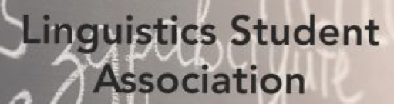

Iran
(Iranian-Persian American Association, IPAA : Camyar Dadashzadeh & Azar Saeedi )

Japan
(Heritage Language teacher and calligrapher, Takashiro Okada)

China
(International Training Programs: Heidi Zhang &. Guan)

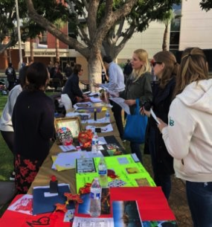
Feb 19, 2020
INTERNATIONAL MOTHER LANGUAGE DAY

CSULB Linguistics Student Association (LSA) and Linguistic Department at California State University Long Beach celebrate Linguistic Diversity
10:00 AM: 3:00 PM :
Speakers’ Platform

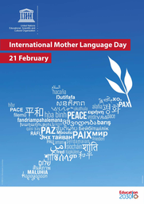

.
- Language Games
- Tongue twisters/finger fumbles from languages around the world
- With American Indian Studies :Make your own “I appreciate and respect you” posters and express how you feel about your mother tongue
- Sociolinguistics Students posters of endangered languages of the world
- Pahka’amo Project and indigenous languages

Center for Community
Engagement
Ivy D. Daulo
Partnership Specialist
Los Angeles Regional Census Center
U.S. Census Bureau

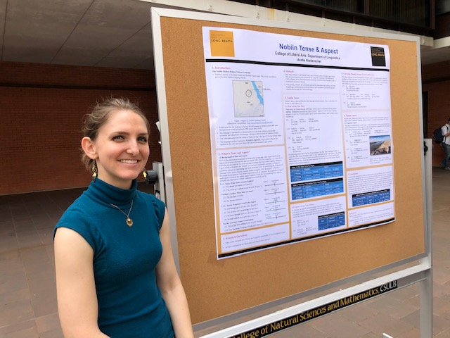

Calligraphy across three cultures


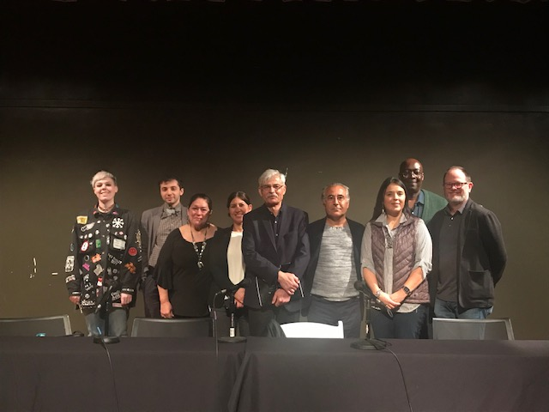
“II appreciate3 and respect you “ and
linguistic diversity on campus
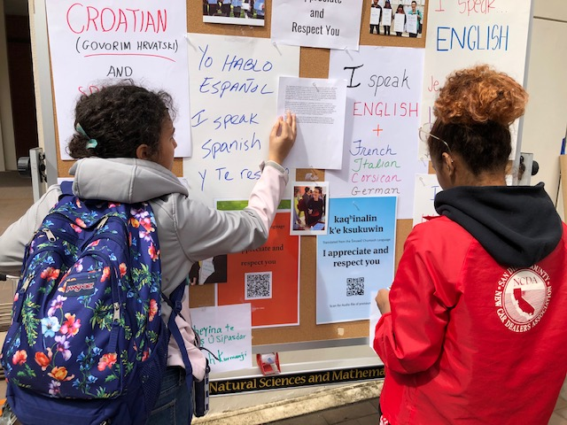I
Dr. Finney: Attitudes toward Contact Induced Changes Affecting the Sierra Leonne Krio
Dr. Donato: Multilingual Education
Dr. LeMaster: ASLD

Panel Discussoin : the Multicultural Center
12:30- 2:30

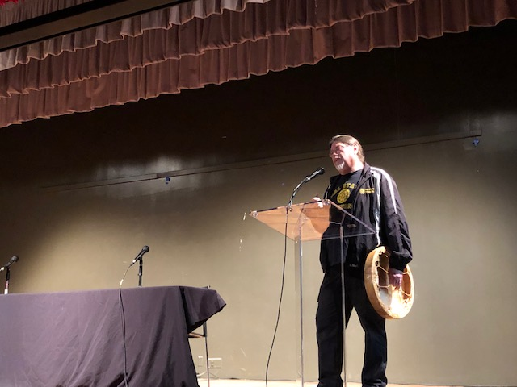Craig Stone: American Indian Studies’ Director and Chair
For details about the program, refer to the link below:
President of Linguistic Student Association
andie.niederecker@student.csulb.edu
SLA’S Facebook:
https://www.facebook.com/groups/csulb.lsa/
LINK TO THE Program
https://en.iyil2019.org/events/international-mother-language-day-2/



DeDrMauris at suspendisse, neque aliquam faucibus

